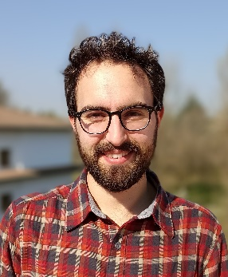
Period of his visit
Dr. Giacomo Titti has visited the CDR from 20 November to 26 November 2022.

Short bio
Environmental Engineer and PhD in Engineering Geology. Since 2017 I worked at the National Research Council of Italy (IRPI) and then at the University of Bologna on landslide risk prevention and mitigation. I'm an expert in Geographical Information Systems, spatial data management and manipulation using Machine Learning algorithms, classification algorithms and optimization algorithms written in Python, R, JavaScript, React and others.
The CDR activities where Dr Giacomo Titti was involved with and carried out while visiting the CDR:
Dr. Titti visited the CDR as part of a long lasting collaboration between the ITC and the University of Bologna (UniBo). His visit prompted a number of future research directions to be explored but also a few past ones to be consolidated. In particular, his previous work of developing software for natural hazard prediction has been recorded in three educational videos that align well with the ITC priorities in open sourcing but also open learning. One of them is already available at this link (https://youtu.be/TN0G7qoAoJ8) while the remaining two are currently in production.
The visit was also the perfect occasion to present his work to the whole Applied Earth Science department and as a result, to set the stage for a wide brainstorming session on how ITC and UniBo can further strengthen their ongoing collaboration.

